//\*test 1

n =10



\*\\

//\*test 2

n = 8

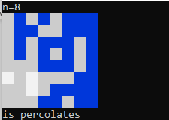

\*\\

//\*test 3

n = -5



\*\\